**Project Description Summary**

In this pandemic situation, most educational institutions and many business organizations conduct their activities over online meeting platforms like Google Meet or Zoom. But these applications only provide a meeting platform. The host needs to monitor the members manually. In the online examinations, teachers need to monitor the students' activities one to one by themselves.

We are planning to build a platform that will provide a video conferencing service. This project's primary purpose is to identify the meeting members by face recognition, monitor their body gestures, and give a summary to the host. Also, it will provide more fair exam policies by object and sound detecting, gestures and motions monitoring and screen freezing during an examination.

**Features:**

* 1. Anyone can sign up and log in to the platform using emails to create a meeting link.
  2. Hosts or admins can create meetings and invite members.
  3. Hosts can schedule meetings for specific times and can get reminders before the meetings.
  4. Members can join a preexisting meeting created and shared by hosts.
  5. If someone tries to join a meeting that the host didn't invite, it will ask for the host's consent to accept that client.
  6. Besides email, each client will be verified by face recognition while joining a meeting.
  7. In a general meeting, clients' body gestures will be monitored, and a summary of the monitored data will be delivered to the host daily or weekly or monthly.
  8. There will be another option to conduct an online examination. During examinations object, noise and gestures detection system will let the host know about using various external things like mobiles, books, or outsiders.
  9. While conducting an examination, the screen freezing feature will give the facility to freeze the device screen after providing the question paper.

**Use Case Diagram:**

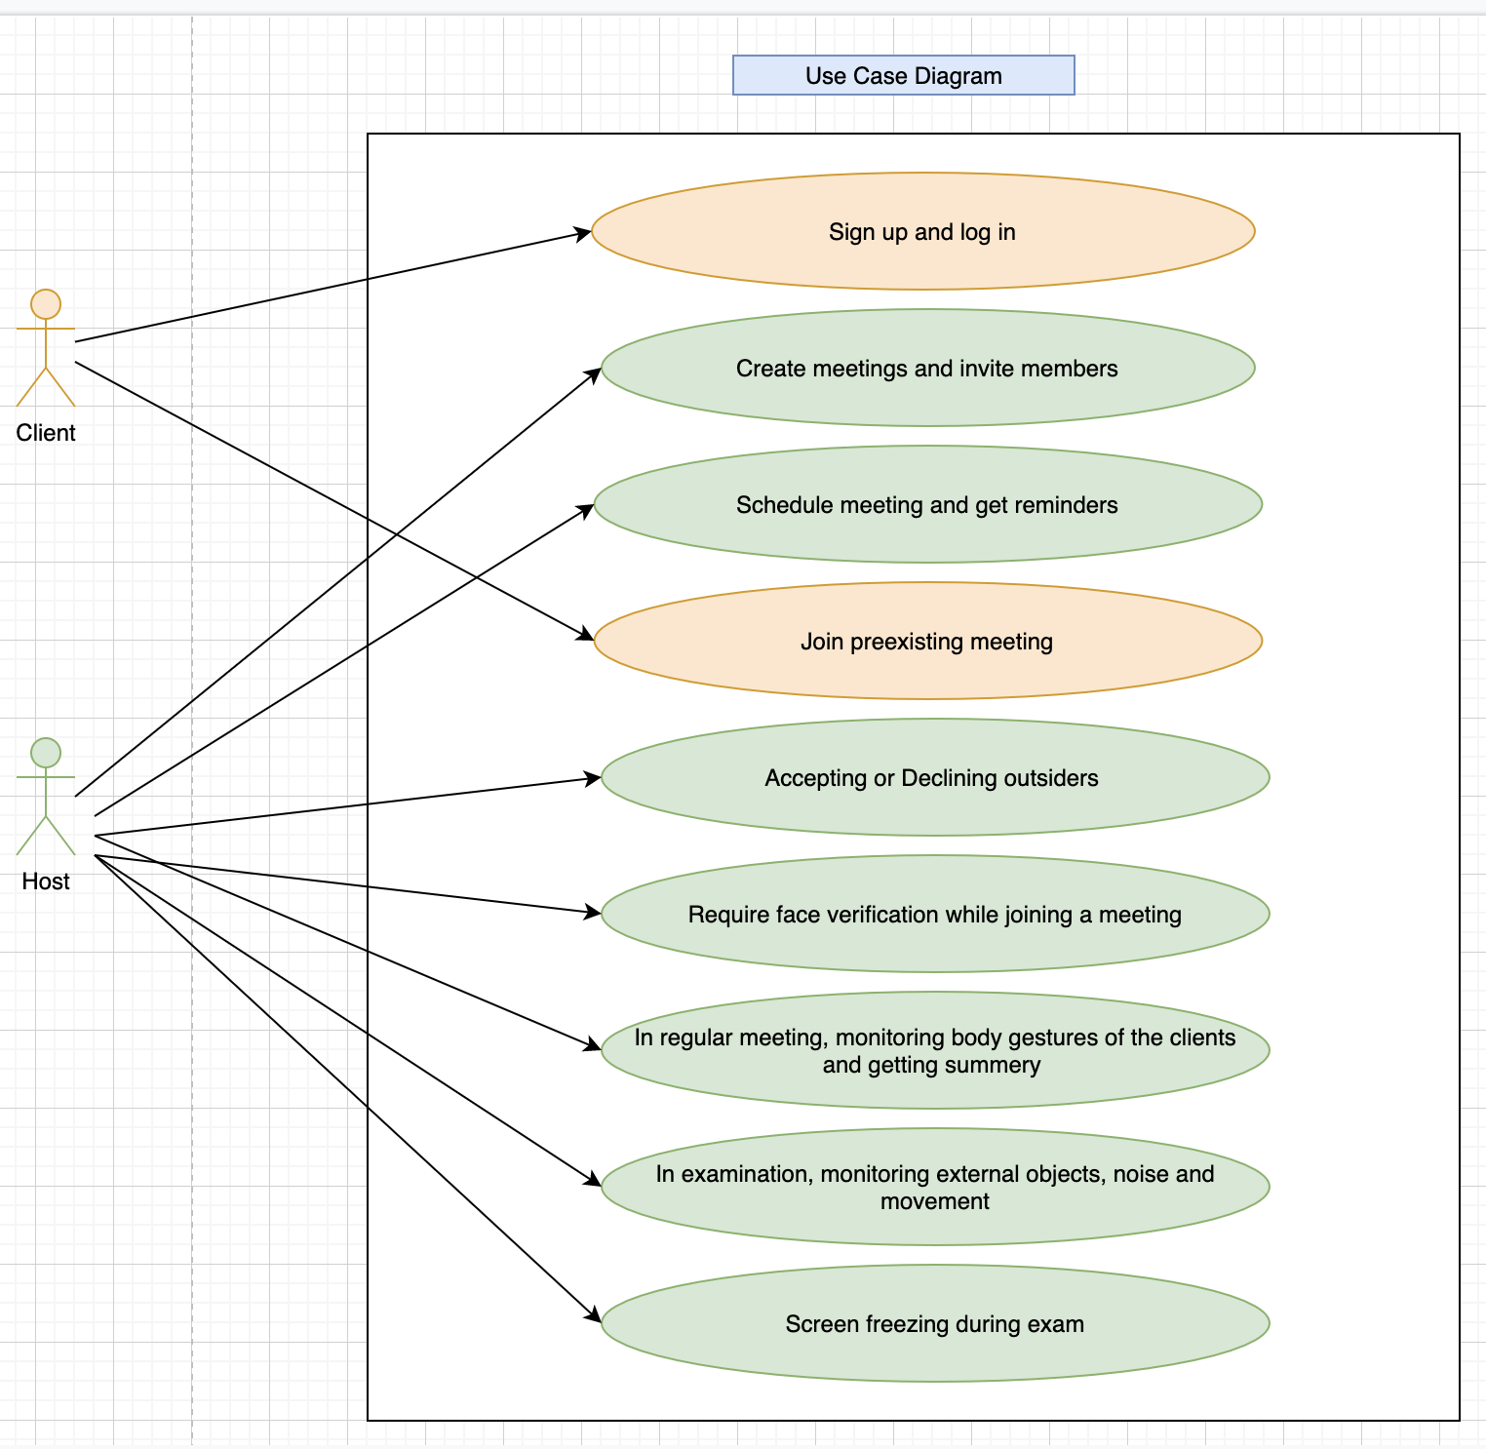

**Figure:** Use Case Diagram